CS 257.00, Intro to Software Design

Professor Amy Csizmar Dalal

January 21, 2020

An Inquiry into the Homepage of Wikipedia

Following the rubric for this assignment, I intend to make an inquiry into a very specific domain – the [homepage](https://www.wikipedia.org/) of Wikipedia. This inquiry takes the form of a report, in that it summarizes the purported purpose of the website, evaluates its navigability and addresses key aesthetic issues.

The **purpose** of Wikipedia is to be a multilingual, online encyclopedia which is editable on an open-source basis.[1]

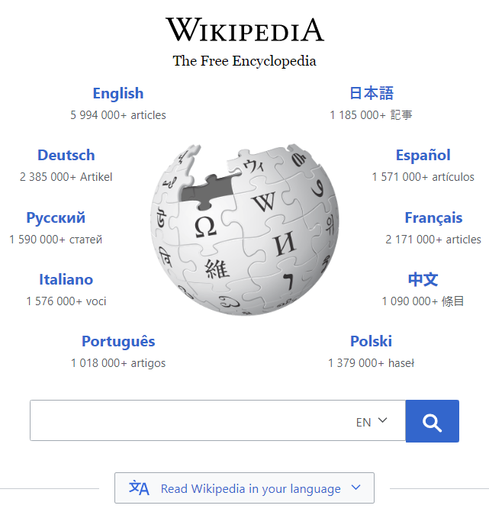As Claire Donald says in her Medium article *An Introduction to Agile Software Development,* Agile is, in a nutshell, “the ability to create and respond to change in order to succeed in an uncertain and turbulent environment”[2]. From an Agile perspective, Wikipedia does an excellent job at maintaining the collaborative process of Agile as not just a commodity skill but as a bespoke (that is, tailored for the users) process of web design which allows quick feedback (most of the editing is actually done by users as well as contributors) between the editors and the users. Wikipedia’s non-profit method of collaborative editing creates a bond between the development team and business stakeholders which allows them to deliver business value (the pursuit of knowledge) almost instantaneously. Thus, the teams are automatically self-organizing and innovative. Before I go into the specifics of how the Wikipedia team implemented Agile, I’d like to address some history regarding its original intention.

Larry M. Sanger, a developer and cofounder of Wikipedia, made a statement that they intended to find an alternative to the traditional use of highly qualified volunteers, in order to generate content “practically instantly” with “very little maintenance” on a “low-risk” basis, with the secondary *potential* of great content on the side; the founders of Wikipedia (Larry Sanger and Jimmy Wales) wanted to create content *rapidly.[3]* This was their intention.

Now, what does the homepage do well in this area (and where can it improve)? Personally, when I look at the figure on the right I have very few questions about where I am. The title, an amalgamation of the prefix wiki- and the suffix -pedia, makes things self-evident without a need for explanation. Links and buttons are obviously clickable (the different language-versions are bold and in blue, the search box is easily recognizable, and the drop-down menu is clearly centered and visible – a nice use of color!).

***Figure 1.*** *The top half of the Home Page, with the classic tagline “The Free Encyclopedia”. Wiki-pedia is portrayed as a global puzzle comprised of many different languages. A true welcome blurb seems unnecessary.*

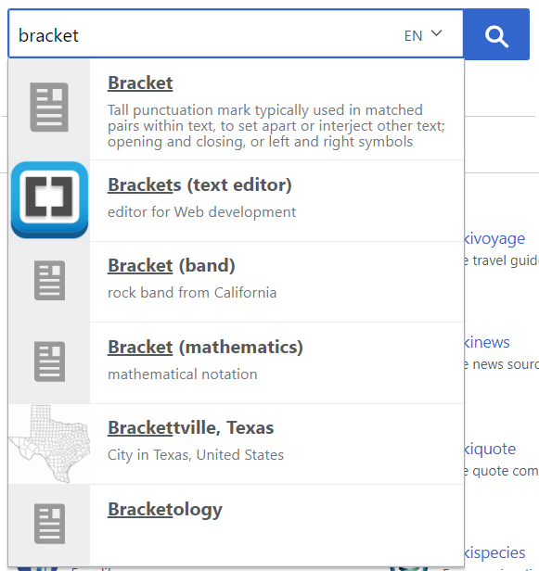If we view the Wikipedia development process in the context of Kanban, I would say that Wikipedia has done an excellent job of not overloading its editors via its method of outsourcing to artificial intelligence, employing verified users and using a backlog system based on clean-up templates dispersed throughout the site.[4] For anyone other than the casual user (for whom the user story is simply to read articles), Wikipedia has a large variety of different user access levels.[5]

When you click the search bar and start typing, it triggers a drop-down menu; Wikipedia takes what you type and gives choices that make sense in order of likelihood. Users have the option to convert the Wikipedia home page into their own language and then search (in their preferred language) for anything they want, doing so with the help of Wikipedia’s smart guessing algorithm which substantially decreases any time, if at all, they spend thinking about where to begin.

If I were a new user, I would wonder where they put the broad categories for different subjects. The company has an official page for categorizing their articles,[6] but this isn’t indicated directly on the homepage. However, this link is not presented on the homepage (probably because it’s not that important; I’m sure they would include it if there were enough requests).

***Figure 2.*** *The search function on the Wikipedia home page is clearly the best. The most obvious guess is at the top and the least obvious is on the bottom, which indicates an effective algorithm for six levels of priority.*

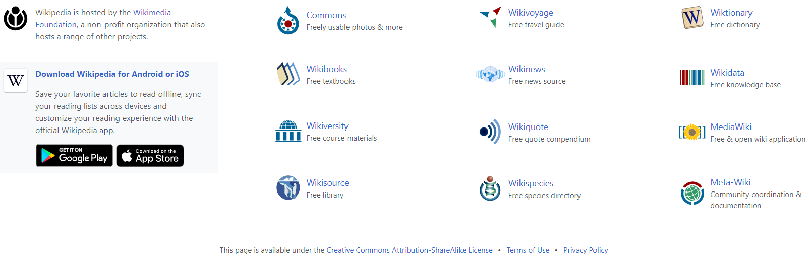

***Figure 3.*** *The bottom half of the homepage. This final visual aspect of Wikipedia’s home page demonstrates importance through its simplicity; self-promotion is on the left, different tools under the same organization heading are on the right (using the trigger word “free stuff”), and at the very bottom are licensing, terms of use and privacy policy descriptions for lawyers, developers and others who are interested.*

On the bottom half of the homepage, the links are consistent with the names of the pages to which they lead. They explain their nomenclature in the text underneath each link, which clears up possible confusion. The *Download Wikipedia for Android or IOS* link on the left takes us to a list of Wikimedia mobile applications, which is a little inconsistent and confusing.

Since Wikipedia functions on user donations, it doesn’t need any advertisements so everything is a part of the site. Furthermore, most users won’t get to this point because Wikipedia has an established reputation as a good encyclopedia – they’re far more likely to use the search function. Thus, users are likely to have very few questions since they view the website as a tool to move to where they want (and they’re unlikely to linger on any one page for too long).

The **navigation** of the site is simple and effective. When we talked about the Carleton website in class, we talked about how the search function used to be pretty limited but now it’s been improved, but regardless of this most web users are going to google what they are looking for and then end up on a random page within the depths of the website. Krug also talks about this in Chapter 7 of his book *Don’t Make Me Think,* where he says that people may be more likely to enter the site by clicking on an external link (and since full orientation on each page isn’t possible, the use of the Home page to get bearings is essential).

The effectiveness of the navigation may not be clear when visiting the home page. However, on every article there’s a list of the site’s main sections. The main page describes featured articles, the news, random insightful facts and historical information about the current day. They have a Contents section describing their entire classification system, a Random article function which allows every page to be viewed, as well as a donation/store link for users who want to buy promotional clothing.

The **key aesthetic issues** of the site are font, paragraph indents and single-spaced text which makes reading it harder. These are simply logistical issues; the site takes maximum advantage of conventions and doesn’t try to innovate; the website logo is clearly shown in the tab, the text and icons are neatly centered with plenty of whitespace on the sides, and the search bar takes advantage of what users are looking for (the universal magnifying glass icon).

***Figure 4.*** *On every Wikipedia article there is a list of the site’s main sections which allows the user to sample various pages, understand what’s available and see connected/related articles. The links we’ve clicked on change color. Although, there’s perhaps a bit too much (the user doesn’t need to select another language once they’re reading).*

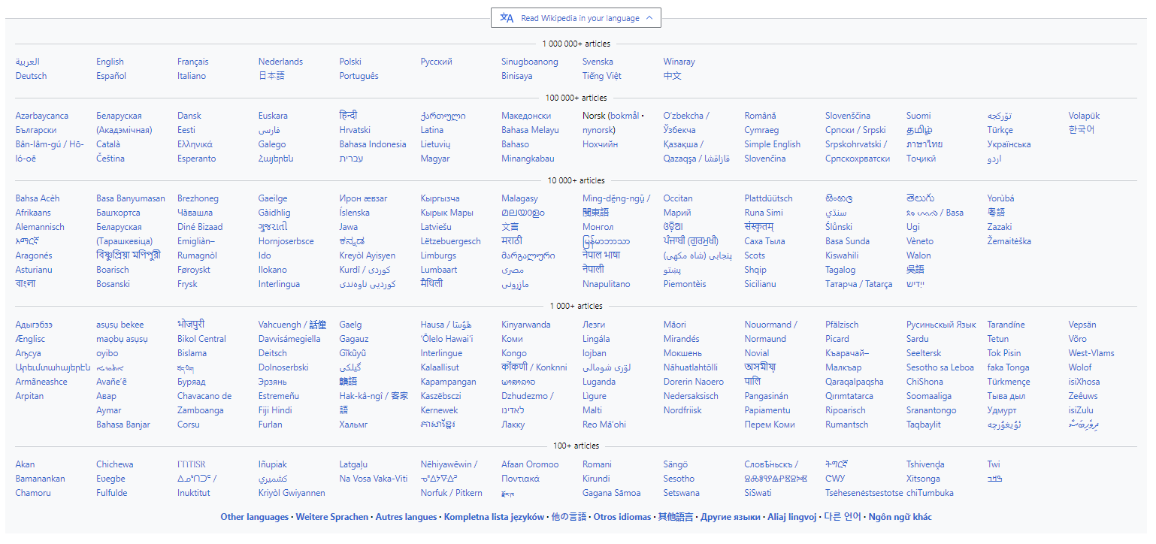However, I think there is a key innovation which provides information which may or may not be useful to the average reader: the drop-down menu for languages is too extensive and it might serve the users better to make this a search function rather than an overly-complicated (segregating them by number of articles) list, through which the user has to sift.

***Figure 5.*** *The drop-down menu for reading Wikipedia in your language is quite extensive; it could be argued that this innovation (giving the total number of articles in each language) is ineffective because it disrupts the user’s ability to follow alphabetical ordering, but it also gives the user a sense of the depth of knowledge.*

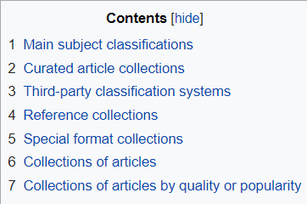I feel like there is a big difference between design/aesthetic issues/consistency and the clarity which these provide to the user; when I look for an article, I am generally trying to do something and it would be helpful for each article to contain more user guides (for programming, for instance). Aesthetically, however, I think Wikipedia does a good job of linking importance with prominence, relating visually objects which are logically related (the visual style of the languages around the central globe is very consistent and the page is broken up into two clearly defined areas) and keeping visual noise to a low level through effective organization. Clutter is optional (it’s allocated to and nested within the drop-down menus).

***Figure 6.*** *On the contents page, and in fact on every page, we can see all the main categories in a box just to the right of center. For Wikipedia, these are the main sections.*

There’s actually very little highlighting and textual explanation to be done – although the website seems to prefer searchers, clicking on the English language link on the main page brings us to the main page, and on the left navigation 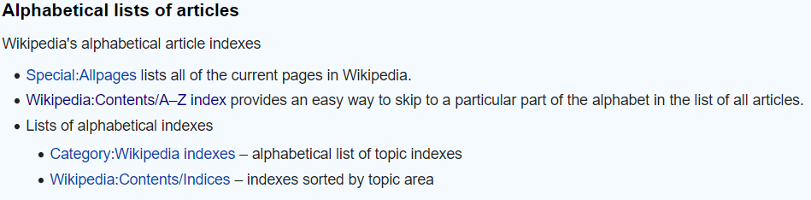bar we can easily access the Contents page, on which we can find Collections of articles and then see all the articles published in alphabetical order.

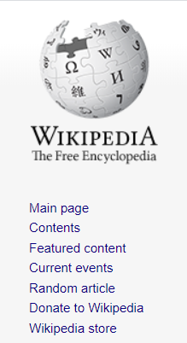 On the Contents page, it is given at the very top of the page that the main subsystems for navigation within the Contents category are Overviews, Outlines, Lists, Portals, Glossaries, Categories and Indices. It’s pretty clear that they put a lot of effort into making sure their website was navigable because their hierarchy allows you to search by so many categories. Although Wikipedia as a huge database with six million English articles in sixteen gigabytes alone,[7] it still doesn’t include breadcrumbs (the trail of websites previously visited, that is, how you got to a certain page). Of course, there is an extension available for download.[8] So if the user gets lost they can easily install the extension, or just find the main page by clicking the Wikipedia logo in the top left (which follows the convention of location); hovering over this logo produces a text box which says “Visit the main page”. There’s a duplicate link right beneath that logo (the “Main page” link), however this isn’t really a big deal.

***Figure 8.*** *The page title will be the title of the bookmark as well, allowing users to easily store their personal shortcuts.*

***Figure 7.*** *Wikipedia’s main Contents page hosts a collection of all articles, sorted by alphabetical order for the user who prefers to browse. It provides a sense of scale for the entire site.*

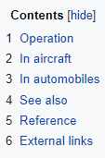 Now, let’s take a step further in evaluating the navigability of the site. Let’s say we reach any page (which isn’t a stub) in one of the major sections (either by Googling it, by following the hierarchy of categories, by searching it using Wikipedia’ universally recognizable search function or by using the “Random article” function visible to the right). If we take any article, say the one on Carburetor heat,[9] we can examine the local navigation at this level.

***Figure 9.*** *From every article, the main page is easily found by clicking either on the logo (which doubles as a site ID) or on “Main page” (yes, this is redundant). Navigation tools like this provide a sense of direction.*

The first piece of navigation is the table of contents, which is pretty self-explanatory. We’ve got the persistent navigation on the left-hand side, which retains our confidence in the ability of Wikipedia’s developers to make things accessible; while they do put a note saying that this particular section doesn’t cite any sources, it’s arguable that providing notes for would-be editors improves the content itself (which is the most important thing) and also provides some reassurance to the users that they have the power 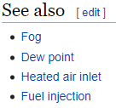to make changes to the website if need be. There are also sections for 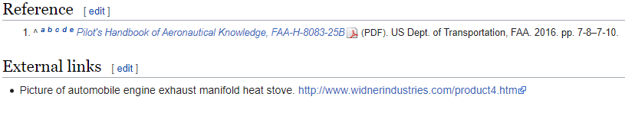References (a big point in establishing trust) and External links.

***Figure 10.*** *Table of Contents. It tells us what’s here. And, it’s collapsible!*

***Figure 12.*** *This set of utilities is mainly for the editors. The casual user wouldn’t know about this. But if they want, tab dividers make it easy.*

***Figure 11.*** *References and External Links are included in every page. This is a matter of Wikipedia establishing its own conventions, and any potential distraction is minimized by their placement at the end of this article about the Carburetor Heat mechanism.*

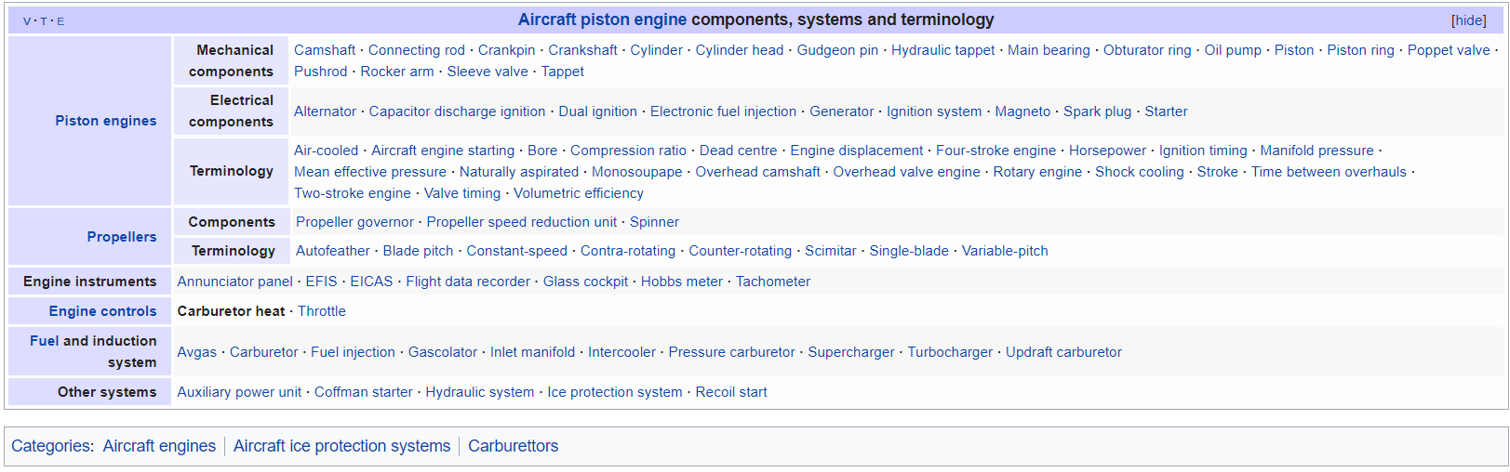Although I would question their implementation of the “You are here” indicator, which seems to be on the bottom of the page rather than on the top as Krug suggests, I think that it is more than enough because not only is it on every page with all the other important elements of persistent site navigation (like Site ID), we’ve got the secondary navigation combined with the “You are here” indicator as follows:

***Figure 14.*** *Clicking the “Aircraft piston engine components, systems and terminology” indicator allows us to see the secondary navigation in its fullest. Although there’s a very low contrast between the View (V), Discuss (T), and Edit (E) symbols in the top left, there are no other obvious issues.*

***Figure 13.*** *The “See also” section provides functionality by adding to the user’s ability and knowledge of how to use the site.*

What meaning can we extract from the color scheme (which is blue or arguably purple if you want)? It’s definitely a soothing color, but shows that Wikipedia’s priorities are following conventions, showing the navigation for all potential levels, naming consistency, avoiding lengthy instructions and making “You are here” indicators obvious, not fancy color schemes or using breadcrumbs as a substitute for thoughtful, omnipresent navigation.

An additional note – we know from experience that when reading an article, we can choose to look at or alternatively ignore the plethora of internal links which are given, within the paragraphs of the text, for various subject matters. This is Wikipedia’s clever way of showing the reader everything they could possibly be looking for in a non-intrusive way. Conceptually, it conveys the big picture via excellently crafted topic sentences. This isn’t the main point – the aesthetic issues with the article are very small but they stem from the attempt to do too much.

In my view, the home page is perfectly done. However, when we get to an internal page (see the example above) we are going to encounter what is, perhaps, too many navigation tools on the left-hand side (I would hardly ever visit the Wikipedia store, not because it’s not good clothing but simply because that’s not my goal when surfing the web). Once a user has selected their language, there’s no need for the language sidebar. We’re not going to need permanent links or related changes unless we’re editors, and even then, the navigation isn’t used nearly as much as the search feature from my observation.

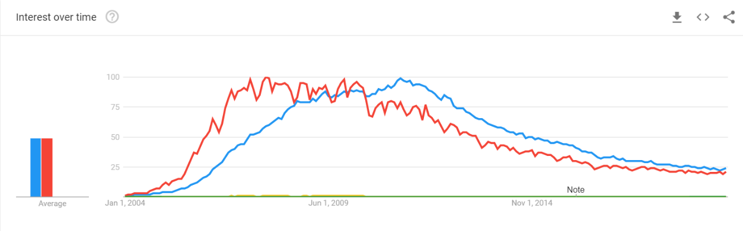Aside from aesthetic issues such as lack of availability of different font types and sizes, no alternative color schemes and a navigation system which does a little too much, I would say that the most important piece of the site to improve is their credibility in terms of content. Although this may not be possible due to the same crowd-sourcing which allows the site to continue to grow with little risk and cost, I think the greatest thing would be for Wikipedia to acquire more credibility; otherwise, users might continue to skim articles to gain a general idea without relying too heavily on the details.

***Figure 15.*** *Google searches for Wikipedia have been dwindling but have stabilized at a medium amount. One possible explanation is that Wikipedia’s navigation and search function has improved sufficiently, since Wikipedia is still expanding rapidly and hasn’t lost significant credibility in the eyes of researchers.*

I think the developers of Wikipedia did a very excellent job of defining where to search (the search box), where to browse (The Main Page with its Content) and where to find interesting pages (Featured Content). I think Krug would say they do a good job of not “killing the golden goose” so to speak – in fact, there aren’t any ads at all and the only thing they do is ask for donations occasionally via a small pop-up bar at the top of the screen. Wikipedia is very transparent about its content-based shortcomings.[10] Furthermore, with regard to the printer-friendly version, I would argue that it is cleaner, easier to read and thus more professional than the electronic version is. The WAVE tool also indicates that there are many problems on the main page with the alternative text (invisible to those who don’t need it). Specifically, there are many duplicate instances of alternative text, which means that screen readers will repeat the same phrases which reduces accessibility. It’s worth noting that the WAVE tool finds no problems with the home page. However, there are numerous redundancies between title attribute text, text and alternative text. While it appears that each Wikipedia article includes several dozen ARIA labels on the navigation bar, its developers might do well to improve accessibility in terms of keyboard-exclusive access as well as screen-reader comprehension.

***Figure 16.*** *When problems are unavoidable, it makes them very clear (declaring that an article needs additional citations for verification, for instance).*

This concludes my report on Wikipedia. I really appreciate being able to write this report and learning about accessibility, so just let me know some suggestions for how I can make things (for example, images and text) more clear.

**References:**

"Backlog". 2020. *En.Wikipedia.Org*. https://en.wikipedia.org/wiki/Wikipedia:Backlog.

“Carburetor Heat.” Wikipedia. The Wikimedia Foundation, Inc., April 9, 2019. https://en.wikipedia.org/wiki/Carburetor_heat.

"Contents/Categories". 2020. *En.Wikipedia.Org*. https://en.wikipedia.org/wiki/Wikipedia:Contents/Categories.

Donald, Claire. 2017. "An Introduction To: Agile Software Development". *Medium*. https://medium.com/shecancode/an-introduction-to-agile-software-development-914339dcec66.

“Extension:BreadCrumbs2.” MediaWiki. The Wikimedia Foundation, March 21, 2019. https://www.mediawiki.org/wiki/Extension:BreadCrumbs2.

“Françoise Combes.” Wikipedia. The Wikimedia Foundation, Inc., December 17, 2019. https://en.wikipedia.org/wiki/Françoise_Combes.

“Google Trends: Compare Searches for Wikipedia and Its Derivatives.” Google Trends. Google, January 21, 2020. https://trends.google.com/trends/explore?date=all&q=wiki,wikipedia,wikipedia.org,en.wikipedia.org

"History Of Wikipedia". 2020. *En.Wikipedia.Org*. https://en.wikipedia.org/wiki/History_of_Wikipedia.

Krug, Steve. 2014. *Don't Make Me Think, Revisited*. 3rd ed. Berkeley, CA: Pearson Education.

"User Access Levels". 2020. *En.Wikipedia.Org*. https://en.wikipedia.org/wiki/Wikipedia:User_access_levels.

"Wikipedia". 2020. *Wikipedia.Org*. https://www.wikipedia.org/.

"Wikipedia". 2020. *En.Wikipedia.Org*. https://en.wikipedia.org/wiki/Wikipedia.

“Size of Wikipedia.” Wikipedia. The Wikimedia Foundation, January 21, 2020. https://en.wikipedia.org/wiki/Wikipedia:Size_of_Wikipedia#Hard_copy_size.

1. ("Wikipedia" 2020)
2. (Donald, 2017).
3. ("History Of Wikipedia; Formulation of the concept" 2020)
4. ("Backlog" 2020)
5. ("User Access Levels" 2020)
6. ("Contents/Categories" 2020)
7. (“Size of Wikipedia” 2020)
8. (“Extension:BreadCrumbs2” 2019)
9. (“Carburetor Heat” 2019)
10. (“Françoise Combes” 2019)